Notes on SQS:- Amazon Simple Queue Service
Amazon Simple Queue Service (Amazon SQS) is a fully managed message queuing service provided by AWS that enables different applications, services, and microservices to communicate with each other asynchronously.
In simple terms, SQS acts like a message mailbox between systems.

How Amazon SQS Works
Imagine:
- Application A generates tasks or messages.
- Instead of sending them directly to Application B, it places them into an SQS queue.
- Application B reads messages from the queue whenever it is ready.
This helps applications work independently without waiting for each other.
Key Features of Amazon SQS
Fully Managed
AWS handles:
- Servers
- Scaling
- Maintenance
- Availability
No infrastructure management required.

Highly Scalable
SQS can process:
- Millions of messages
- Large workloads
- Traffic spikes automatically

Reliable & Durable
Messages are stored redundantly across multiple AWS servers.

Secure
Supports:
- IAM policies
- Encryption with AWS KMS
- HTTPS communication
Types of SQS Queues
1. Standard Queue
Features
- High throughput
- Best-effort ordering
- At-least-once delivery
Best For
- General-purpose applications
- High-speed processing
Example
Log processing systems

2. FIFO Queue (First-In-First-Out)
Features
- Exact message order preserved
- No duplicate processing
Best For
- Financial transactions
- Payment systems
- Order processing
Example
Banking applications

Important Concepts
Visibility Timeout
When a consumer reads a message:
- The message becomes temporarily invisible to others.
- Prevents multiple consumers from processing the same message simultaneously.
If processing fails, the message becomes visible again.

Dead-Letter Queue (DLQ)
Stores messages that fail processing multiple times.
Useful for:
- Debugging
- Error handling
- Preventing queue blockage

Long Polling
Consumers wait for messages efficiently instead of repeatedly checking the queue.
Benefits:
- Reduces costs
- Improves performance
Example Real-World Scenario
E-Commerce Website
Without SQS
If payment service becomes slow:
- Entire application slows down.
With SQS
- Orders go into SQS.
- Payment service processes messages independently.
- Website remains responsive.

Advantages of SQS
Benefit | Description
Loose Coupling | Services work independently
Reliability | Messages are not lost
Scalability | Handles huge traffic
Fault Tolerance | Systems continue working during failures
Cost Effective | Pay only for usage

SQS vs SNS
Amazon SQS | Amazon SNS
Message Queue | Pub/Sub Notification Service
Messages stored | Push notifications
One consumer processes message | Multiple subscribers receive message
Pull model | Push model
Interview-Friendly Definition
Amazon SQS is a fully managed message queuing service that enables distributed applications and microservices to communicate asynchronously, improving scalability, reliability, and fault tolerance.
Created a new SQS in AWS:
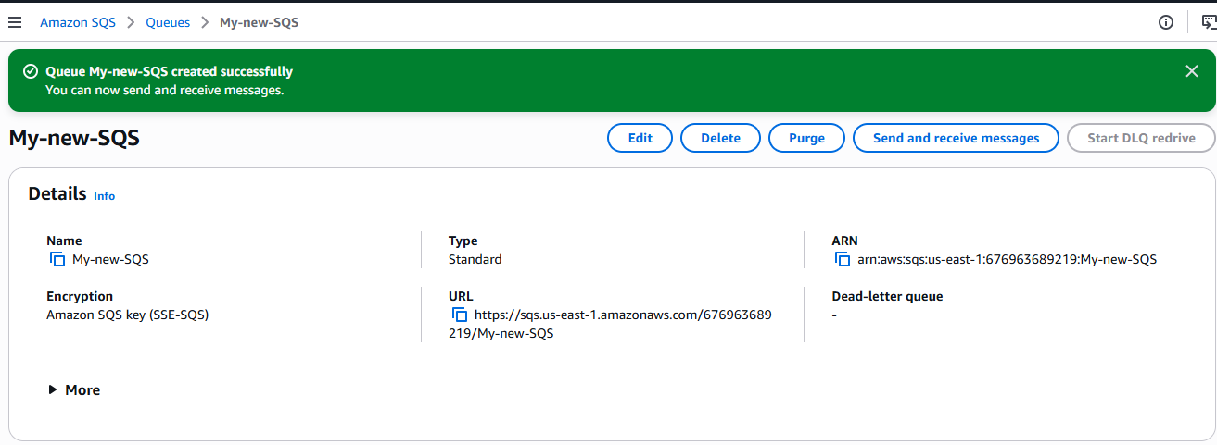
Then click on send and receive messages and then click on send message and type the required message:
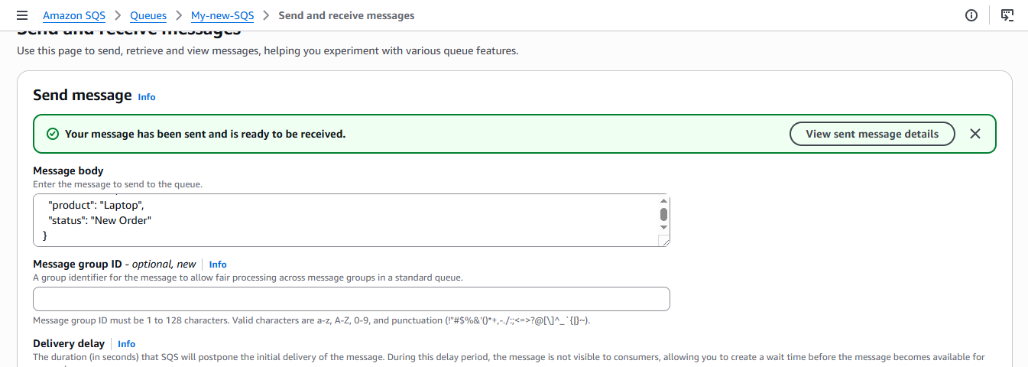
Then scroll down and click on receive message option and then poll message and then click on the message you see on the screen and then you will be able to see the message:
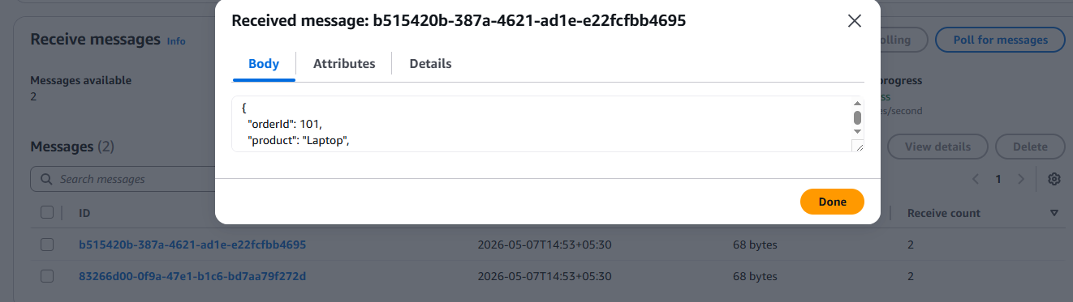
task on MQ
Created a new broker in MQ:
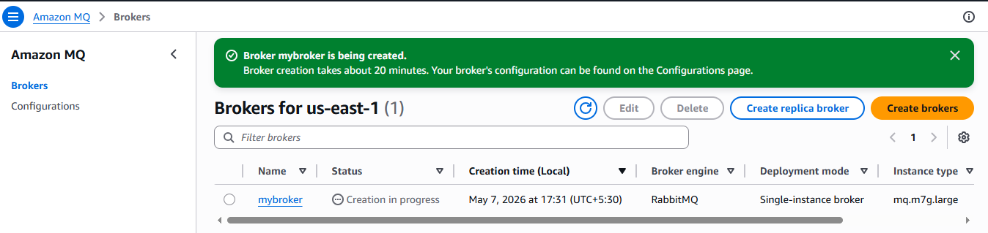
Broker started running after 20 minutes:
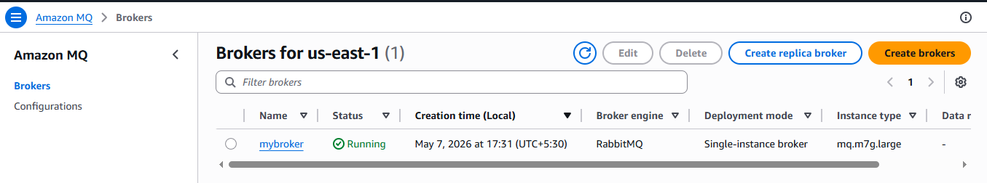
Then click in web console:
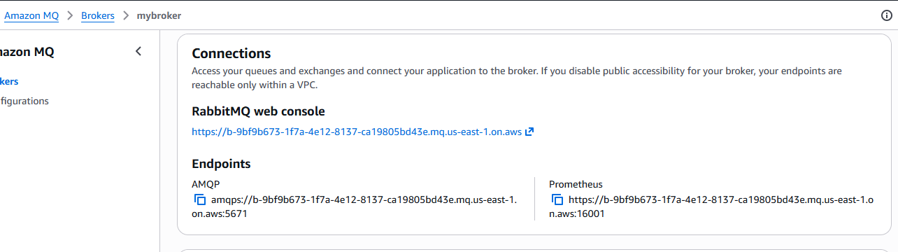
Once you click on it login with username and password provided in broker creation step and then click on queues and streams and then click on your name: 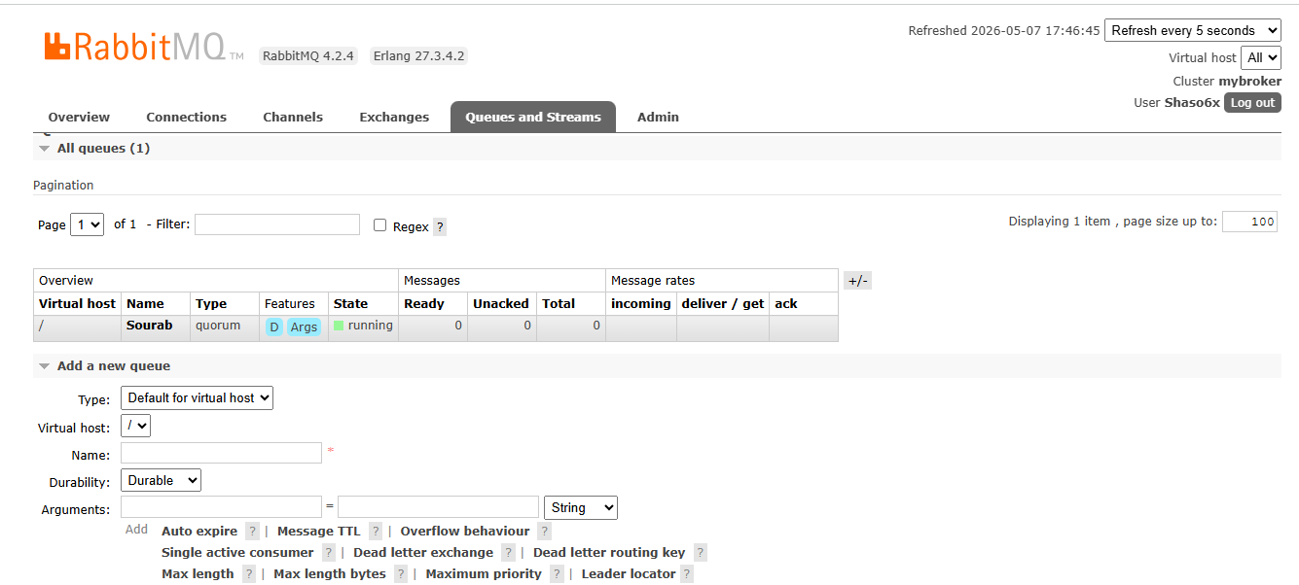
Once you click on your name then go to publish message and the payload and then type message then and then click on publish message and then click on get message: 